A synopsis

on

**“DMR-based optimization of LNG Liquefaction via MCHE parameters & MR composition variation in Aspen Plus Simulation Software”**

In partial fulfilment of the requirements for the degree of

Bachelor of Technology

Submitted By:

Maryam Banoo (2000040510013)

Sanyam Dixit (2000040510021)

Radhakrishna Pathak (2100040519005)

Sanjit Pal (2100040519006)

Tooba Parsa (2100040519008)

Under the guidance of:

Dr. Shraddha Rani Singh

(HOD-Chemical Department)

Department Of Chemical Engineering

R.B.S Engineering Technical Campus, Bichpuri, Agra  
Batch: 2020 - 24

**Table of Contents**

|  |
| --- |
| 1. Keywords |
| 1. Abstract |
| 1. Introduction |
| * 1. Global Energy Demand |
| * 1. Natural Gas & Liquified Natural Gas |
| * 1. LNG Process |
| 1. Literature Review |
| * 1. Current Technologies & Advancements |
| * 1. MR Liquefaction Technology Analysis |
| * + 1. Single Mixed Refrigerant (SMR) |
| * + 1. Pre-cooled Mixed Refrigerant (PMR) |
| * + 1. Double-mixed refrigerant (DMR) |
| * + 1. Dual-Effect Single Mixed Refrigerant (DSMR) |
| * 1. Analysis of Heat Transfer in Heat Exchanger |
| * 1. Analysis of the MR composition |
| * 1. Gaps in previous research |
| * 1. Future Scope |
| * 1. Research Focus |
| 1. Methodology |
| * 1. Steps Involved |
| * 1. Optimization & Simulation Work |
| 1. Acknowledgment |
| 1. Credit Authorship Contribution Statement |
| 1. Nomenclature |
| 1. List of Figures |
| 1. References |

* **KEYWORDS:**

Main Cryogenic Heat Exchanger (MCHE), Liquefied Natural Gas (LNG), Aspen Plus Software, Double Mixed Refrigerant (DMR), Parameter & Composition Variation, Optimization

* **ABSTRACT:**

This research endeavors to enhance the liquefaction process of Liquified Natural Gas (LNG) by strategically varying parameters within the Main Cryogenic Heat Exchanger (MCHE). The primary objective is optimizing efficiency while minimizing energy consumption, contributing to a more sustainable and cost-effective LNG production. The study employs basic simulation and modeling techniques in Aspen plus Simulation Software to analyze the impact of varied MCHE parameters & MR composition on the overall liquefaction process. Through systematic experimentation and data analysis, this project aims to identify optimal configurations that balance operational efficiency and energy conservation. The outcomes of this research hold the potential to improve the sustainability and economic viability of LNG production significantly, addressing key challenges in the energy sector.

* **INTRODUCTION:**

1. **Global Energy Demand**:

Energy and petrochemical process plants consist of unit operations such as separators, valves, expanders, compressors, and heat exchangers. Each of these unit operations contributes its own set of more or less realistic thermodynamic equations as well as mass and heat balances. Such equation systems normally have a few degrees of freedom. The units are linked to each other by the material and energy streams with another set of process variables, such as flow rate, pressure, and temperature. The challenging task is to minimize the investment and operating costs of the plant concerning these process variables.

1. **Natural Gas & Liquefied Natural Gas**:

NG is the cleanest fossil fuel with abundant proven reserves. It is the third largest primary energy source after crude oil and coal. It contains mainly methane (about 90%), ethane, propane, butane, and trace amounts of nitrogen and CO2. It is nontoxic, colorless, odorless, and non-corrosive. NG has already established itself as a major and/or alternate source of fuel to supplement energy demand and curb the over-dependency on oil. In 2007, NG consumption was 2637.7 million tons of oil equivalent, or about 23.8% of the total primary energy consumed worldwide. The usage is projected to increase by nearly 52% between 2005 and 2030 (IEO, 2008). NG is also a fast-growing and the second-largest energy source for electric power generation, producing 3.4 million GWh in 2005 with a projection of 8.4 million GWh in 2030 (IEO, 2008). NG-fired combined cycle generation units have an average conversion efficiency of 57% (**Kjärstad & Johnsson, 2007**), compared to 30% to 35% efficiency for coal.

However, the storage and transportation of NG is a critical technology and cost issue. Pipelines pose security risks and are not always feasible or economical. They are often limited by a ‘ceiling’ amount of NG that can be transported. Alternately, an attractive option is to liquefy NG at the source and then transport it as LNG by specially built ships. Liquefaction reduces the volume of NG by a factor of about 600 at room temperature and facilitates bulk transport. LNG is the most economical means of transporting NG over distances of more than 2200 miles onshore and 700 miles offshore (**Thomas & Dawe, 2003**).

LNG provides an excellent example of Design-For-Logistics or DFL products (**Lee, 1993**). More than 90% of the feed heating value in a modern LNG plant is shipped as product LNG. The demand for LNG as an alternate fuel is doubling every ten years. The tendency to diversify energy sources for better energy security and new technology LNG ships are among the factors behind the recent increase in LNG demand. In 2007, 226.41 billion cubic meters of NG were transported as LNG (BP SRWE, 2008), accomplishing a total LNG movement of about 165.3 million tons per annum (MTPA). LNG is stored again and re-gasified before it is supplied to the consumers.

The LNG supply chain is capital-intensive, mainly due to cryogenic liquefaction and transportation. Although it has been considered costly and rigid since the early days, recent improvements in liquefaction and transportation technologies are transforming LNG into an increasingly favorable energy commodity. **[2]**

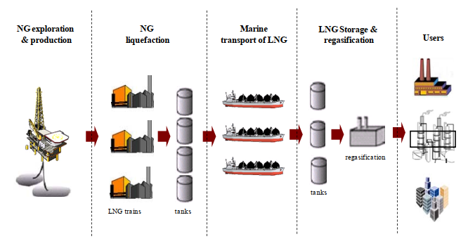

Fig 1: Schematic of a typical LNG supply chain

1. **LNG Process:**

Figure 2 & 3 shows a simplified configuration of an LNG process & a typical LNG plant. NG is first treated to remove condensates, acid gases, sulfur compounds, water, and mercury. The treated gas is then cooled to and liquefied at around -163 °C and atmospheric pressure to produce LNG. Often partially liquefied NG is fractionated to remove heavier hydrocarbons and produce natural gas liquid (NGL).

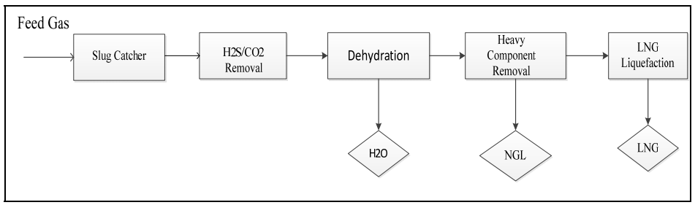

Fig 2: Block Diagram of a Typical LNG Plant

Refrigeration is used to liquefy NG. Depending on the technology, single or multiple refrigeration cycles in series, parallel, or cascade are used. A multi-stream heat exchanger (MSHE) is at the heart of this refrigeration, which produces and sub-cools LNG.

This MSHE is usually known as the main cryogenic heat exchanger (MCHE) in LNG plants. Plate & fin, spiral-wound, and multi-pass shell & tube are the most common types of MCHEs. Normally, a low-pressure refrigerant flow, down the shell side of MCHE to cool and liquefy NG on the tube side.

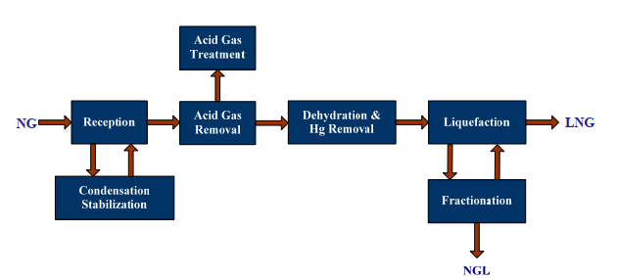

Fig 3: LNG Process Block Diagram

Many LNG plants integrate heat and power using various energy networks. Heat is integrated using a network of heaters, coolers, and exchangers. Such heat exchanger networks (HENs) can be developed only when the total heat requirement of all process streams is known. In some LNG plants, fuel gas networks (FGNs) collect fuels from various sources within the plant and distribute them to turbine drivers, generators, boilers, etc. Although HENs are well studied and applied, FGNs are a relatively more recent activity in LNG plants.

* **Literature Review**:

1. **Current Technologies & Advancements:**

Since natural gas is a multi-component mixture, liquefaction will occur at a sliding temperature interval.

Two main approaches are used to design energy-effective LNG processes, cascade processes, and multi-component refrigerant cycles. In mixed refrigerant processes, such as the Prico process, the cold composite curve is matched to the hot composite curve using a single refrigeration cycle with a mixed working fluid that will evaporate at a sliding temperature interval; hence only one compressor is needed. An alternative to the Prico process is the Phillips Cas-cade, which consists of three pure working fluids, propane, and ethylene methane, each cycle with up to three pressure stages. In this way the cold composite curve from the refrigerants can be nicely matched with the natural gas hot composite curve, however, several compressors and heat exchanger passes are needed. In most commercial large-scale LNG plants as the Mixed Cascade Refrigeration (MCR) process by APCI and Mixed Fluid Cascade (MFC) by Statoil-Linde, the LNG process is a combination of the cascade and mixed refrigerant process. **Barclay and Denton (2005)** have provided an overview and description of LNG processes.

The cryogenic industry has had its early start since Dr. Carl von Linde developed air and gas separation technologies in the nineteenth century in Munich, Germany. The LNG industry started its early development by using LNG technology for natural gas peak shaving. Peak shaving is a strategy used by the power industry to store natural gas for peak demand that cannot be met by their typical pipeline volume.

At first, the cascade cycle was used in LNG plants. Later, A. Klimenko presented the mixed refrigerant concept (Dr. Chen-Hwahiu, 2008) at the LNG-1 Conference. Air Products applied its mixed refrigerant cycle to the Libya Marsa El Brega LNG plant. Afterward, Air Products improved the cycle to create the propane pre-cooled mixed refrigerant (C3-MR) cycle, which is being used in more than 80% of LNG plants globally. Phillips Petroleum invented the cascade liquefaction cycle (Dr Chen-Hwahiu, 2008). This cascade cycle is a closed-loop cycle of propane, ethylene, and methane refrigerants. Interestingly, when the C3-MR cycle was built at the Brunei LNG plant, the cascade cycle was built for the Kenai LNG plant in Alaska, and Prichard’s all-MR cycle was built later in Africa. A newer version of Phillips’ open loop cascade cycle has been built in Trinidad and several other places such as Egypt, Darwin, and Equatorial Guinea.

Early contributors to the LNG industry include Lee Gaumer and Chuck Newton who invented the all-mixed refrigerant cycle and the C3-MR cycle for Air Products’ LNG process. The Wilkes Barre cryogenic facility has manufactured the coil wound LNG Main Cryogenic Heat Exchangers (MCHE) since the late 1960s. Ludwig Kniel of Lummus invented a cascade cycle and regasification plant synergy for an ethylene plant. Ludwig also introduced a nitrogen expansion cycle as a subcooling section for the LNG process (Dr. Chen-Hwahiu, 2008). Dr C. M. “Cheddy” Sliepcevich pioneered and managed the research, development, and implementation of the first commercial process for liquefaction and LNG ocean transport during his work with Chicago Stock Yards and Continental Oil Company at the University of Oklahoma. For his pioneering research in LNG technology, Cheddy, also referred to as the “Father of LNG”, received the Gas Industry Research Award from the American Gas Association Operating Section in 1986 in Seattle. The award, sponsored by Sprague Schlumberger, honored his scientific achievement in LNG research and his contribution to LNG safety. Some of his students, **Bahareh Salehi (2018),** have further developed his work in LNG safety.

In the beginning, steam turbines were preferred for LNG plant application because of their prevalence in oil refineries. Steam turbines were implemented at the Bontang LNG plant in Badak, Brunei, and Das Island LNG plants. Later, it was discovered that gas turbines could be more economically applied in LNG plants, and, therefore, new LNG plants started using gas turbines.

As gas turbine drivers are being improved, the water-cooled exchangers are being changed to ambient air-cooled heat exchangers. This is attributed to two factors: one is the concern over water temperature changes and the second is because of the simple and more efficient use of large ambient air-cooled exchangers.

Heat exchangers used in LNG are classified into coil-wound heat exchangers and plate-fin core exchangers.

Coil-wound heat exchangers have evolved from smaller sizes to reach an approximate 15- feet diameter and approximately 200 feet in height and weigh up to 300 metric tons, including thousands of tubing capable of holding internal pressure up to 1,100 psig. Currently, Air Products and Linde manufacture these cryogenic heat exchangers and it can take up to 25 months to complete one exchanger.

Plate-fin exchangers are manufactured by several vendors and are much cheaper than coil-wound heat exchangers. Variations include core-in-kettle exchangers. These exchangers are manufactured by vacuum brazing the aluminum components into the whole exchanger and require shop testing for high-pressure performance.

Phillips Petroleum developed the close-loop optimized LNG cascade cycle and improved it in the early 90s to what is known today as the open-loop process cycle. For mixed refrigerant cycles, there are the Pritchard PRICO cycle and Air Products all MR and C3-MR cycles. There are also other cycles by some French companies. Conoco Phillips’ optimum cascade cycle can be built in large LNG plants up to 8+ MTPA. This process is being used in LNG plants built in Darwin, Egypt, and Equatorial Guinea and will be used in the Angola LNG plant.

Irrespective of the refrigeration process employed, LNG plants are extremely expensive to operate; hence, there have been several studies on optimizing the process. Most of these studies have focused on optimizing operational expenditure (OPEX) with only a handful addressing capital expenditure (CAPEX). The main aim of optimizing operating expenditure has been to minimize the gap between hot and cold composite curves, which is what primarily affects the process efficiency. Some specific examples of such studies include the work of Shah et al. (**Shah, Rangaiah & Hoadley, 2009**), who optimized two objective functions simultaneously, namely, capital expenditure and energy efficiency, and **Jensen and Skogestad (2009)**, who included capital expenditures as a portion of the optimization investigation of the single mixed refrigerant (SMR) process.

**Ait-Ali’s (1979)** optimization study on mixed refrigerant process operation proved to be a major contribution to the refrigeration processes. However, it was strictly restricted to the optimization computational methodology dominant at that time. Importance was placed on decreasing the compressor’s power and numerous simplifications were considered to attain that target.

**Gao, Lin, and Gu (2009)** performed an optimization study on an LNG process for coal bed methane (CBM) within the simulation package HYSYS. In the research, Gao et al. (2009) did not incorporate butane as a component of the mixed refrigerant though butane composition had a significant consequence on optimum performance. In addition, propane was tuned as constant; hence, the residual component flows were permitted to vary until the minimum value for the objective function was achieved. Regarding the optimization objective, the consumed compressor power and shared production flow rates were minimized.

The optimization was performed using a consecutive method, related to the method of **Lee et al. (2002)**, which could not ensure inclusive optimality. The system’s key parameters were optimized in sequential order: composition of components, discharge pressures, and temperatures of the heat exchanger.

**Kanoglu et al. (2001)** highlighted the advantages of replacing the Joule Thomson valve (JT) instead of the turbine expander for LNG expansion units.

**Mortazavi et al. (2010)** observed the impact of substituting expansion valves with liquid turbines and two-phase expanders on the capacity and efficiency of the propane pre-cooled multi-component refrigerant (MCR) natural gas liquefaction cycle licensed by Air Products

**Gandhi Raju (2009)** specified the ‘acclaimed’ composition of mixed refrigerants for precooled systems claiming the ‘optimal’ composition of refrigerant. Gandhi Raju (2009) proposed that using and executing the technology in operational plants is challenging, as the necessary compositions differ intensely with varying plant conditions and schemes. An essential method of assessing efficiency is the closeness between the cold and hot composite curves. The technology cannot demonstrate the temperature profiles for the shown refrigeration compositions. However, the points between these cold and hot composite curves differ between 7 deg C and 12 deg C, which specifies process inefficiencies. The author concluded that it is possible to achieve even greater efficiencies and/or higher amounts of refrigeration with suitable variations to the composition of refrigerant and/or the operating/design condition.

**Castillo et al. (2012)** in their paper “Conceptual analysis of the precooling stage for LNG processes” made a comparison between different precooling cycles for LNG processes which were carried out through computational simulation using Aspen HYSYS. The paper aimed to provide future development with a clear idea of the technical advantages and disadvantages involved in the selection of the process for the precooling cycle. The results of the research revealed that 3 stages propane precooled was found to be the most energetically efficient among studied cases, even better than a two-stage mixed refrigerant process (C2/C3) for both climate conditions, warm (25°C) and cold (6°C) respectively. However, due to the reduced power share that may be reached with a propane cycle temperature restriction, the mixed refrigerant precooling cycle is the preferred alternative under cold climate conditions.

**Paradowski et al. (2004)** performed parametric research on a pre-cooled propane mixed refrigerant cycle. Their study investigated mixed refrigerant composition, propane cycle pressures, precooling temperature, and propane cycle compressor speed. The study focused on the importance of the propane-mixed refrigerant cycle even for larger plants than those already constructed, consequently maintaining its position as the first option liquefaction cycle.

**Saffari (2010)** optimized the energy efficiency of an industrial pre-cooled propane mixed refrigerant LNG base load plant by varying the components of refrigerants and the mole fractions in liquefaction and sub-cooling cycles. This process was simulated using the HYSYS software. The Peng Robinson equation of state was used for thermodynamic calculations of properties both for natural gas and refrigerants. Two approaches for modeling and optimization were studied and some parameters were evaluated.

1. **MR Liquefaction Technology Analysis**

There have been tremendous developments in liquefaction technology in recent years.

For mixed refrigerant cycles, there is the single mixed refrigerant cycle and the double mixed refrigerant developed by Shell. Shell also developed the Parallel MR cycle, which utilizes the split casing propane compressor arrangement. The Axen’s Liquefin cycle is essentially a dual mixed refrigerant cycle. Air Products has developed the AP-X™ cycle to plant capacity up to 8+ MTPA. Linde and Statoil invented the mixed fluid cascade cycle, which is being applied to the Snohvit LNG plant in the Arctic region of Norway. An all-electric drive configuration is being used in Snohvit LNG to increase overall liquefaction efficiency. Further, cryogenic liquid expanders are now commonly used in liquefaction processes to increase liquid production.

One of the most critical and challenging sections of an LNG plant is the refrigeration section, which consists of a rather complicated mechanical refrigeration system to produce the low temperature required for liquefaction. The following types of MR liquefaction processes can be considered to accomplish this task:

1. Single mixed Refrigerant Process (**SMR**)
2. Pre-cooled mixed Refrigerant Process (**PMR**)
3. Double mixed Refrigerant Process (**DMR**)
4. Dual Effect Single Mixed Refrigerant Process (**DSMR**)

The development of LNG technology has responded to growing LNG demand with innovations in liquefaction technology, coupled with energy integration of the LNG chain. Soon, we can imagine an increase in global liquefaction capacity, LNG storage, and LNG ship size. The sites for LNG liquefaction plants or receiving terminals will expand to include offshore areas.

1. **Single Mixed Refrigerant Process (SMR):**

* Uses a single mixed refrigerant throughout the liquefaction process.
* Follows a simpler process configuration with a single mixed refrigerant loop.
* May have limitations in terms of flexibility and efficiency optimization due to the use of a single mixed refrigerant.
* Typically has a fixed temperature profile for the entire liquefaction process.
* Generally simpler in terms of design and potentially lower in cost due to the use of a single mixed refrigerant.

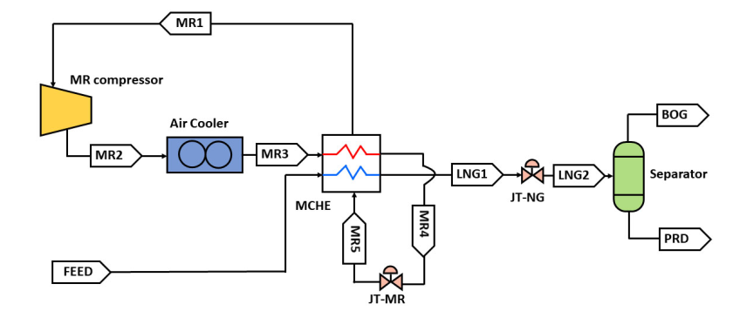

Fig 4: SMR Liquefaction Process for NG

1. **Pre-cooled Mixed Refrigerant Process (PMR):**

* Utilizes two separate mixed refrigerants – one for pre-cooling and the other for the main liquefaction cycle.
* Involves a more complex setup with distinct mixed refrigerants for pre-cooling and the main liquefaction cycle, allowing for better heat exchange efficiency.
* Offers improved efficiency compared to SMR by employing a separate refrigerant for pre-cooling, allowing for better temperature control.
* Allows for better temperature optimization with distinct temperature profiles for pre-cooling and the main liquefaction cycle.
* Involves a more complex design and may have higher associated costs due to the use of two separate mixed refrigerants and additional equipment for pre-cooling.

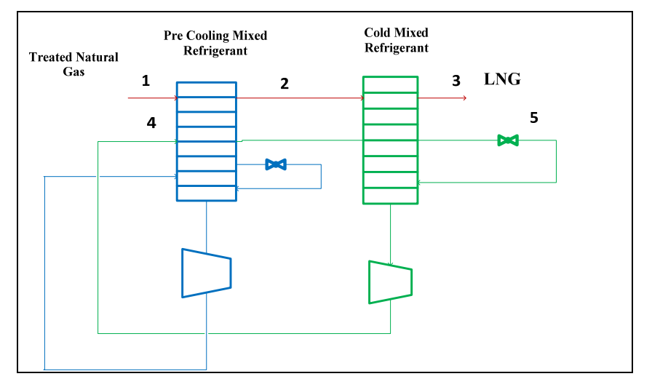

Fig 5: PMR Liquefaction Process for NG

1. **Double Mixed Refrigerant Process (DMR):**
   * Incorporates two mixed refrigerants, each serving a specific purpose in the liquefaction process, providing additional flexibility for optimization.
   * Employs a dual-loop system with two separate mixed refrigerants, offering increased control over the heat exchange process and overall efficiency.
   * Provides enhanced flexibility and efficiency by using two distinct mixed refrigerants, allowing for more precise control over the cooling process and improved overall performance.
   * Enables precise control over temperature profiles in both the pre-cooling and liquefaction stages, contributing to higher efficiency.
   * While more complex than SMR, DMR offers a balance between complexity and efficiency, allowing for better optimization without excessively increasing costs.

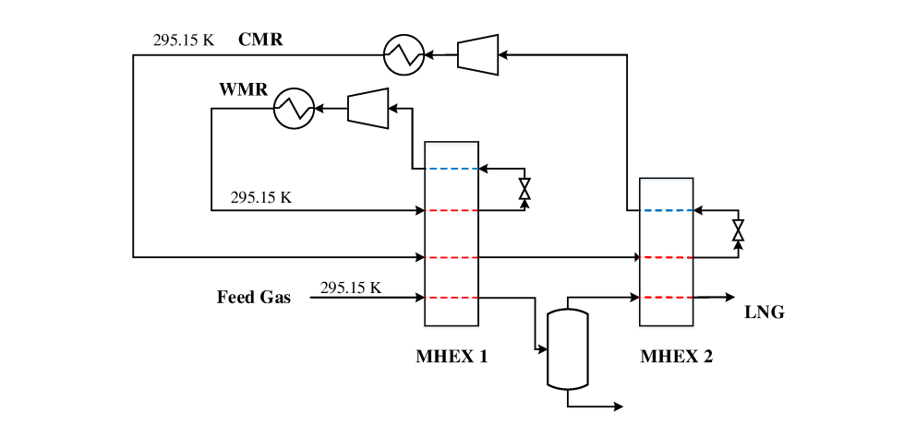

Fig 6: Dual Mixed Refrigerant (DMR) model with cascading PRICO cycles for the warm and cold MR Streams

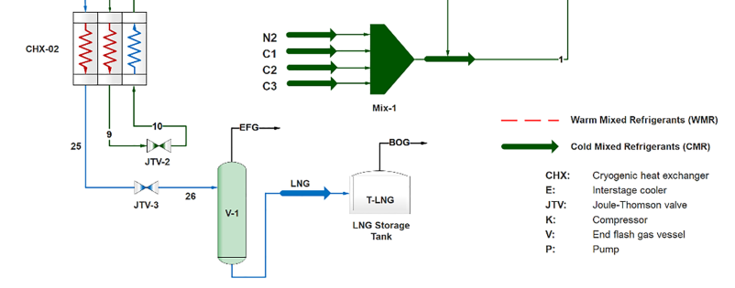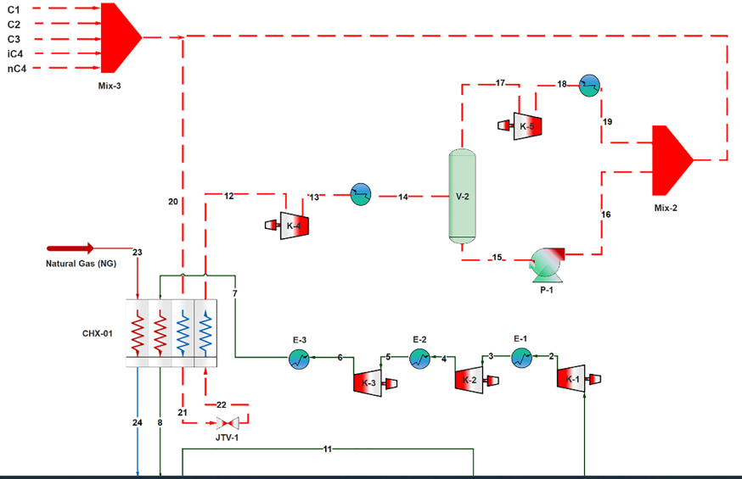

Fig 7: Convectional DMR Process

1. **Dual-Effect Single Mixed refrigerant (DSMR):**

* The Dual Effect Single Mixed Refrigerant (DESMR) process involves combining two or more refrigerants with different thermodynamic properties to create a single mixed refrigerant. This composition blend is carefully designed to optimize the overall cooling performance.
* The "Dual Effect" refers to the use of two separate refrigeration stages within the process. Each stage operates at a different temperature level, allowing for more efficient heat transfer and improved overall system performance.
* By utilizing two stages and a carefully chosen mixed refrigerant composition, the DESMR process achieves enhanced efficiency in the cooling cycle. This can result in improved energy utilization and reduced operational costs compared to traditional single-stage refrigeration processes.
* The DESMR process is versatile and can be applied to various industrial refrigeration and liquefaction applications, such as natural gas processing, petrochemical production, and liquefied natural gas (LNG) plants. Its adaptability makes it suitable for a range of temperature and capacity requirements.

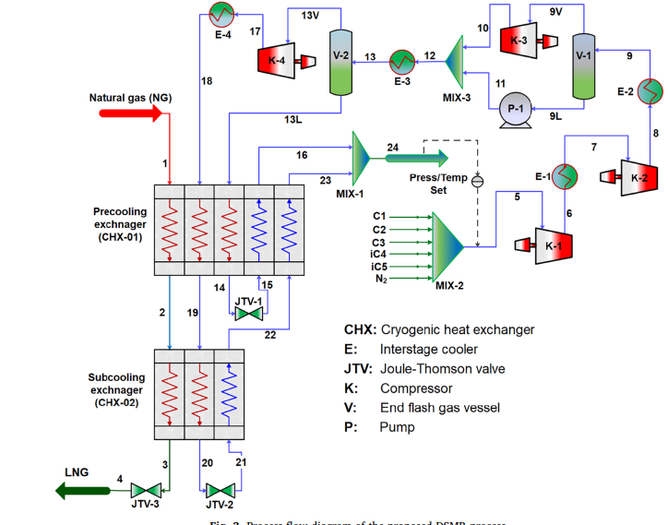

Fig 8: Convectional DSMR Process

1. **Analysis of Heat Transfer in Heat Exchanger**

The two most important unit operations in an LNG process are the compressors and the heat exchangers. In general, increasing the size of the heat exchangers will decrease the power requirement in the compressors and thereby increase the efficiency. Eq. (1) gives the relationship between the heat transferred from the hot stream to the cold stream Q, the overall heat transfer coefficient U, the size of the heat exchanger A, and the driving forces, represented by the logarithmic mean temperature difference (LMTD) between the hot and the cold streams. Eq. (2) shows the definition of the LMTD for counter-current flow.

Q = U · A · del TLM … (1)

LMTD = del TLM = (TH, in − TC, out) − (TH, out − TC, in)

ln [(TH, in − TC, out)/ (TH, out − TC, in)]

For the same heat (Q) and overall heat transfer coefficient (U), there is an inversely proportional relationship between the size of the heat exchanger (A) and the driving force (del TLM). Large driving forces will lead to irreversibility in the heat exchanger, which again will increase the need for energy transferred to the process through the compressor, and thereby both the investment cost and the operational cost for the compressor will increase.

On the other hand, if the heat exchanger (HX) is large (small driving forces) then the HX investment cost will increase while the compressor investment and energy costs will be reduced. Hence, there is always a trade-off between the size of the HX and the size of the compressor.

Since LNG processes are very energy-intensive, the minimum internal temperature approach (MITA) is usually small. A temperature difference of 2 ◦C is often used in the early design phase. Even if the trade-off between compressor power and driving forces in the HX is fixed (e.g. by specifying an MITA of 2 ◦C), there are still several variables that can be optimized. Whether the LNG process is good or not can often be seen from the shape of the hot and cold CCs. In general, the area between the CCs should be as small as possible, the pinch point should be in the cold end of the HX (MITA) and gradually open up at higher temperatures. There is always degeneration of exergy (irreversibility) associated with a heat transfer process operating across finite temperature differences. For an infinitesimal amount of heat del Q extracted from a hot stream at temperature TH, and an ambient temperature of T0, the inherent change in exergy is given by Eq. (3).

On a similar basis, the exergy supplied to the cold stream at temperature TC is given by Eq. (4). The total irreversibility due to heat transfer between two streams can be expressed as Eq. (5) and Eq. (6), where c is the Carnot factor. It should be noted that the normal sign convention in thermodynamics is not applied, thus the infinitesimal amount of heat del Q is regarded as a positive entity. From the equations, it can be concluded that exergy losses due to temperature driving forces in the heat exchanger depend on the total duty of heat to be transferred and the temperature difference, and that they are largest at a low temperature.

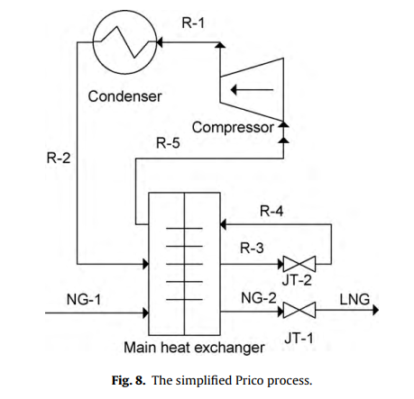

Fig 9: MCHE in Prico Process

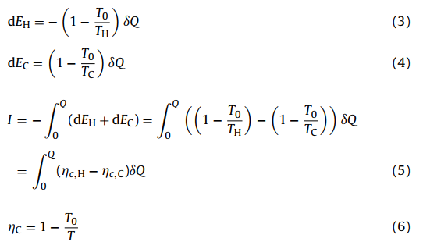

The Prico process as shown in Fig. 3, is a simple LNG process using a multi-component mixture as the working fluid. It consists of a main heat exchanger, a compressor, a condenser, and two Joule-Thomson (JT) valves. Two compressor stages with intermediate cooling will increase the efficiency, however, the variables will remain the same, and hence, one stage is used in the calculations for simplicity. In the current example, the natural gas (NG-1) enters the main heat exchanger at a pressure of 60 bar and 20 ◦C where it is cooled, liquefied, and subcooled (NG-2) before it is expanded to transport pressure (LNG). The cooling duty is provided by a simple refrigeration cycle using a multi-component working fluid consisting of nitrogen, methane, ethane, propane, and butane. At high pressure (R-1) the working fluid is cooled and partly liquefied in a condenser by cooling water or ambient air.

The working fluid (R-2) is then sub-cooled in the main heat exchanger (R-3) before it is expanded to low pressure through a JT-valve (R-4). The expansion leads to a small decrease in temperature and some gas will be formed. This cold fluid at low temperature and low pressure is vaporized to provide cooling and liquefaction of both the refrigerant and the natural gas close to a counter-current heat exchanger. At the outlet of the heat exchanger, the refrigerant will be in the gaseous phase (R-5) and it is then compressed to high pressure (R-1) before the heat is removed to the surroundings in the condenser (R-2). In the optimization, the outlet temperatures from the main heat exchanger of the hot streams (R-3) and (NG-2) are kept equal. **A. Aspelund. (2010**)

1. **Analysis of the MR composition**

**Mohd Zaki (2014)**, The exergy efficiency of any mixed refrigerant process depends on the mixture’s constituents and their concentration. The exergy efficiency of MRC refrigerators will be high when a second liquid phase occurs in the evaporator. Liquid-liquid immiscibility is observed at low temperatures in multicomponent mixtures of nitrogen– hydrocarbon, fluorocarbon–hydrocarbon, fluorocarbon–hydrochlorofluorocarbon, and fluorocarbon–hydrofluorocarbon refrigerants This immiscibility can be exploited to obtain a near-constant temperature evaporation with mixtures with both binary and multicomponent mixtures. The liquid-liquid immiscibility also allows us to reach temperatures close to the boiling point of the low boiler in the mixture.

Consider a refrigerator operating with nitrogen-hydrocarbon mixtures. The power drawn by the compressor is related to the flow rate or the refrigerant pressure at compressor suction. Most off-the-shelf domestic refrigeration and air conditioning compressors are designed to operate below 5–6 bar to limit the amount of current drawn by the compressor motor. Applying the 5-bar limit, one can realize that the maximum evaporating temperature is 94 K in the case of nitrogen-hydrocarbon mixtures. Argon-hydrocarbon mixtures can be used for higher refrigerating temperatures. Because of the lower vapor pressure of argon, the volumetric cooling capacity would always be lower in the case of argon-hydrocarbon mixtures than nitrogen-hydrocarbon mixtures at refrigeration temperatures lower than 94 K, as is the case with Linde–Hampson refrigerators operating with pure argon and nitrogen. In most cases, the upper limit for nitrogen-hydrocarbon mixtures to obtain near-constant temperature evaporation is about 104 K when the pressure drop in the heat exchangers and the difference between the boiling point of nitrogen and the bubble point of nitrogen-hydrocarbon mixtures are also taken into account. Argon, hydrocarbon mixtures need to be used above this temperature. Nitrogen-hydrocarbon mixtures can be used at much higher temperatures if a small temperature change is tolerated in the evaporator. Temperatures lower than the boiling point of the low boiler (for example, nitrogen) can also be obtained by adding a non-condensable fluid such as helium, hydrogen, or neon. These non-condensable fluids, however, inhibit the formation of liquid-liquid immiscibility at low temperatures (see Fig. 4.16). Propane freezes below a temperature of 69 K in most nitrogen-helium-methane-ethane-propane mixtures. A similar limit is observed in mixtures where neon is used instead of helium. High boilers such as isobutane and pentane freeze at much higher temperatures.

The lowest operating temperature is thus decided by the concentration of the high boilers as well as by the compressor lubricating oil in the refrigerant. Mixtures of tetrafluoromethane (refrigerant R14), tri-fluoro-methane (refrigerant R23), and butane or propane show liquid-liquid immiscibility at low temperatures and can be used for temperatures above 145 K [55]. Liquid-liquid immiscibility is also observed in mixtures of refrigerants R14-R23-R22 [55]. Refrigerant R22, however, is a

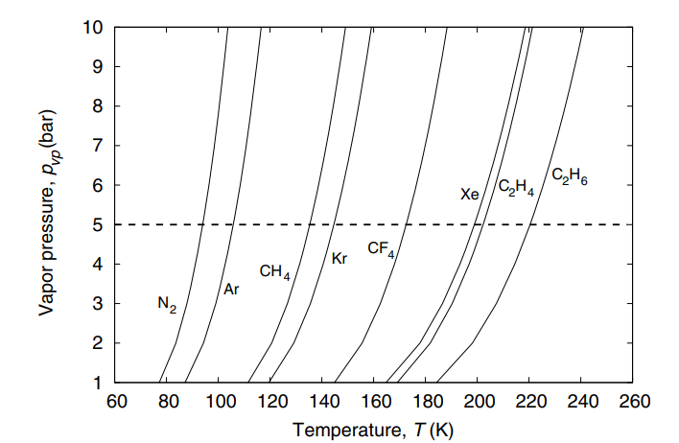

Fig 10: Vapor Pressure of Different Fluids

hydrochlorofluorocarbon and cannot be used in new refrigerators in many countries. Refrigerant R22 can be replaced by one or more hydrofluorocarbon refrigerants such as R218, R125, R143a, R134a, R227ea, RC318, etc. Temperatures below 145 K can be obtained by adding a non-condensable fluid such as argon, nitrogen, neon, or helium to fluorocarbon mixtures of R14-R23-R22, etc. The method for determining the most basic components of a nitrogen-hydrocarbon mixture was first given by Alfeev et al. in their patent [7]. These principles can be extended to other fluid mixtures also. The guidelines for choosing the components of a mixture are as follows:

• Choose a first fluid whose boiling point temperature at 1.5 bar is less than the desired refrigerating temperature. For example, nitrogen can be used for temperatures between 80 and 105 K, tetrafluoromethane (Refrigerant R14) between 150 K 5.2 Optimization of mixture composition for refrigeration processes 131 and 180 K). A mixture of nitrogen and argon can be used between 105 and 140 K, and argon between 120 and 150 K, etc.

• Choose a second fluid whose boiling point is about 30 to 60 K above that of the basic fluid and that does not exhibit liquid-liquid immiscibility at low temperatures with the primary fluid. For example, one can choose methane with argon and nitrogen, trifluoromethane (R23) with tetrafluoromethane (R14), etc.

• Choose a third fluid that exhibits a liquid-liquid immiscibility at low temperatures with the first fluid and whose boiling point is at least 30 K above that of the second fluid, for example, ethane, ethylene, etc., which exhibit liquid-liquid immiscibility at low temperatures with nitrogen. Ethylene also exhibits a liquid-liquid immiscibility at low temperatures with argon [87]. Propane, butanes, and chlorodifluoromethane (R22) exhibit a liquid-liquid immiscibility with R14 (tetrafluoromethane) [55].

• Choose a fourth fluid that exhibits a liquid-liquid immiscibility at low temperatures with the first fluid, for example, propane or butanes with nitrogen.

• Choose an optional fifth fluid that exhibits a liquid-liquid immiscibility at low temperatures with the first fluid, for example, pentanes with nitrogen. A minimum quantity of third and fourth fluids is required for the multicomponent mixture to exhibit liquid-liquid immiscibility at low temperatures. It is also possible to use fluids that do not exhibit liquid-liquid immiscibility at low temperatures with the first fluid as the component of the mixture. For example, a mixture of argon, methane, ethane, and propane does not exhibit liquid-liquid immiscibility at low temperatures. However, the bubble point of the mixture will be substantially higher than that of the first fluid. The refrigeration temperature of such a mixture can be decreased by adding a non-condensable fluid, for example, neon, or helium in the case of argon-hydrocarbon mixtures, or nitrogen or argon in the case of fluorocarbon mixtures. It is also advantageous to use non-condensable fluids with nitrogen-hydrocarbon mixtures (see Section 4.5). Some authors [57] have advocated the use of more than five components. The choice of the optimum mixture components and concentration, however, can only be determined using an optimization model and a process simulation program.

1. **Gaps in previous research**
2. **Limited Focus on MCHE Parameters**: Previous studies may have insufficiently explored the potential of optimizing liquefaction through variations in MCHE parameters. This project aims to fill this gap by specifically targeting the Main Cryogenic Heat Exchanger for efficiency improvements.
3. **Absence of an Ideal MR Composition**: The composition of the Mixed Refrigerant (MR) plays a critical role in the liquefaction process, and some previous research may not have thoroughly investigated the impact of MR composition variations on efficiency and energy consumption.
4. **Future Scope**
5. **Complexity of Simulation Models**: The simulation of LNG liquefaction processes can be complex, involving intricate thermodynamics and fluid dynamics. This project acknowledges the challenge and aims to navigate through the complexity using Aspen Plus Simulation Software while maintaining accuracy and reliability in results.
6. **Data Variability and Uncertainty:** Real-world operational conditions can be variable, leading to uncertainties in simulation outcomes. The project acknowledges this challenge and intends to address it by conducting systematic experimentation to capture a range of possible scenarios and enhance the robustness of the findings.
7. **Integration of MCHE Parameters and MR Composition**: Coordinating variations in MCHE parameters and MR composition introduce an additional layer of complexity. The challenge is to establish a systematic and effective approach for exploring the combined impact of these factors on liquefaction efficiency.
8. **Practical Implementation**: Bridging the gap between simulation results and practical implementation in real LNG plants can be challenging. This project recognizes the importance of ensuring that the optimized configurations identified in simulations are feasible and implementable in real-world scenarios.
9. **Research Focus**

To ***model*** and ***simulate,*** using Aspen Plus, the performance of the MCHE process by changing parameters such as flow rates, pressure, composition of Mixed refrigerant, etc., and then study the post-effects of these changes in downstream equipment, connected to the DMR refrigeration cycle.

* **Methodology:**

1. **Steps Involved**
2. ***Acquiring knowledge and information about MCHE***: Information such as the geometrical properties of MCHE, correlations for heat transfer calculation, and phase equilibrium will be identified. Other than that, the method for simulating the MCHE will be determined.
3. ***Simulating and verifying the proposed MCHE by using Aspen Plus Simulation Software***: Once all the criteria for developing the simulation are confirmed, the activity for developing the simulation can be validated using Aspen Plus. The simulation’s results will be verified against the experimental result.
4. ***Collecting and analyzing data from the field***: The operating data from the field will be collected and it will be analyzed in terms of its reliability and suitability for the study.
5. ***Scaling up the simulation and implementing the data***: The simulation built earlier will be scaled up to the actual process. Once it is ready, the collected data will be implemented in the completed simulation.
6. ***Verifying and analyzing the result:*** The simulation’s result will be verified against the expected result obtained from the study or the actual process condition.

Then, it will be analyzed especially for the relationship between refrigerant composition and heat integration performance.

1. ***Implementing and evaluating the proposed solution for improving the MCHE***: Based on the analysis, a suitable solution will be proposed for improving the MCHE.

It will be then implemented in the simulation to investigate its impact on the overall liquefaction process. The feasibility of the proposed solution will be evaluated technically and economically.

1. ***Simulating the proposed solution of MCHE for examining the different compositions of MR***: Based on the efficient parameters combination for MCHE parameters, a suitable combination of Mixed Refrigerants will be proposed for improving the process efficiency for minimizing energy consumption.

Overall, the simulation built will be used as a tool to analyze the effect of various compositions of mixed refrigerant on the performance of MCHE. This can be done by having the heating and cooling curve between the natural gas stream and refrigerant stream for analyzing the efficiency of the liquefaction process. However, other methods of analysis may be used for this purpose as well.

1. **Optimization and simulation work**
2. Several assumptions have been proposed for developing this simulation. Below is the list of assumptions made for this simulation:

* The system is assumed to be in steady-state condition and there are no changes in operating conditions over time.
* No heat is dissipated from the system to the surrounding environment.
* Heat is assumed to be transferred from the bulk fluid to the surrounding wall of tubes. There is no change of heat in the longitudinal flow of fluid.
* Heat is transferred uniformly across the tube wall.
* There is no significant change in terms of fluid phase across the heat exchanger. It is assumed that only one phase will take place inside the heat exchanger.
* It is also assumed that the heat transfer coefficient is constant for the position, temperature, and time.
* The distribution of the flow is assumed to be uniform across the heat exchanger on the fluid in each side and each pass. There should not be an accumulation of flow inside the heat exchanger.
* Heat is assumed to be constant in heat flow. The system must have a balanced heat transfer from one medium to another.

1. Initial Feed Conditions:

|  |  |  |  |
| --- | --- | --- | --- |
| **Parameter** | **Value** | | |
| Feed Flow Rate | 0.96 | 0.97 | 0.98 |
| Nitrogen (mol%) | 2.00 | 2.00 | 2.00 |
| Methane (mol%) | 85.60 | 87.60 | 89.60 |
| Ethane (mol%) | 6.93 | 5.93 | 4.93 |
| Propane (mol%) | 3.71 | 2.71 | 1.71 |
| n-Butane (mol%) | 1.35 | 1.35 | 1.35 |
| i-Butane (mol%) | 0.40 | 0.40 | 0.40 |
| i-Pentane (mol%) | 0.01 | 0.01 | 0.01 |

1. Characteristics of Optimal Design:

|  |  |
| --- | --- |
| **Characteristic** | **Variable(s)** |
| 1. High Heat Transfer Coefficient 2. Low Pressure drops 3. Small Space or area | * Stream Temperatures * Flow rates of Streams * Fouling Factor * Fluid Properties (Density, Specific Heat, Viscosity, Thermal Conductivity, etc.) * Varying the use of different correlations for calculating heat transfer coefficient in Aspen Plus |
| 1. Low Temperature Crossover | * Minimum temperature approach > zero |
| 1. Gas should liquify completely (no vapor fraction) | |
| 1. Simulation can be done for various operating conditions such as: 2. Variation in feed composition 3. Variation in ambient temperature 4. Variation in flow rates. | |

* **Acknowledgement:**

The authors would like to give full gratitude to the Department of Chemical Engineering, RBS Engg Technical Campus, Agra (UP), for giving them a chance to conduct research in this area.

* **Credit Authorship Contribution Statement:**

**Dr. Shraddha Rani Singh:** Project Mentor, Formal Analysis & Supervision

**Sanyam Dixit:** Conceptualization, Methodology, Investigation, Software Modelling, Writing & Drafting

**Radhakrishna Pathak:** Visualization, Reviewing & Editing

**Maryam Banoo:** Data Curation

**Sanjit Pal:** Formal Analysis, Data Curation, & Software Modelling

* **Nomenclature:**

The following abbreviations are used in this manuscript:

1. MCHE – Main Cryogenic Heat Exchanger
2. SMR – Single Mixed Refrigerant
3. DMR – Dual/ Double Mixed Refrigerant
4. MR – Mixed Refrigerant
5. LNG – Liquified Natural Gas
6. NGL– Natural Gas Liquids
7. MCR – Mixed Cascade Refrigerant
8. JTV – Joule Thomson Valve
9. DSMR – Dual Effect Single Mixed Refrigerant
10. WMR – Warm Mixed Refrigerant
11. CMR – Cooled Mixed Refrigerant
12. MITA – Minimum Internal Temperature Approach

* **List of figures:**

1. Fig 1: Schematic of a typical LNG supply chain, pg. 2
2. Fig 2: Block Diagram of a Typical LNG Plant, pg. 3
3. Fig 3: LNG Process Block Diagram, pg. 4
4. Fig 4: SMR Liquefaction Process for NG, pg. 9
5. Fig 5: PMR Liquefaction Process for NG, pg. 10
6. Fig 6: Dual Mixed Refrigerant (DMR) model with cascading PRICO cycles for the warm and cold MR Streams, pg. 11
7. Fig 7: Convectional DMR Process, pg. 12
8. Fig 8: Convectional DSMR Process, pg. 13
9. Fig 9: MCHE in Prico Process, pg. 15
10. Fig 10: Vapor Pressure of Different Fluids, pg. 17

* **References:**
* **A**. Aspelund, T. Gundersen, J. Myklebust, M.P. Nowak, A. Tomas Gard (**2009**) An optimization-simulation model for a simple LNG process, Elsevier, Computers and Chemical Engineering 34 (2010) 1606-1617
* **A**mer mortazavi et al, (**2010**), enhancement of APCI cycle efficiency with absorption chillers, Elsevier, energy 3877_3882
* **A**it-Ali, M. A., (**1979)**, "Optimal Mixed Refrigerant Liquefaction of Natural Gas," Ph.D. Dissertation, Mechanical Engineering Department, Stanford University, Stanford, CA.
* **B**ahareh Salehi (**2018**), LNG Plant Modelling and Optimization – Thesis, Dept of Chemical Engg, School of Chemical & Petroleum Engg.
* **B**arclay, M., & Denton, N., (**2005**). Selecting offshore LNG processes. LNG Journal,34-36
* **D**el Nogal F, Kim JK, Perry S, Smith R. (**2008**) Optimal design of mixed refrigeration cycles. Industrial & Engineering Chemistry Research.; 47:8724–8740.
* **F**rank Del Nogal et. al (**2008**), Synthesis of cryogenic Energy System, Elsevier, Computer Aided Process Engg., 67-72
* **G**. C. Lee et. al. (**2002**), Optimal synthesis of MR system for low-temperature process, Ind. Eng. Chem. Res., 41, 5016-2028
* **G**andhiraju, V., (**2009**). United States patent application
* **H**arry A.J Whatson et. al. (**2015**), Multistream heat exchanger modeling & Design, AIChe, Heat Exchangers, 3390-3403
* **H**eng Sun et. al. (**2019**), Simulation Study of Liquefaction of low-pressure unconventional natural gas, Elsevier, Cryogenics, 101,22-28
* **H**amidreza Taleshbahrami, Hamid Saffari., (**2010)**, Optimization of the C3MR cycle with genetic algorithm, Journal of Computation and Engineering
* **H**. Paradowski, M. Bamba, C., (**2004**). Propane precooling cycles for increased LNG train capacity, in 14th International Conference and Exhibition on Liquefied Natural Gas, pp.107-124.
* **J**. Myklebust, M.P. Nowak, A. Tomas Gard (**2009**) An optimization-simulation model for a simple LNG process, Elsevier, Computers and Chemical Engineering 34 (2010) 1606-1617
* **J**i-Hung Hwang et. al., (**2013**), Optimal Design of Liquefaction Cycle of LNG Floating Production, Storage & off-loading unit considering optimal synthesis, I&EC research, Cryogenics, 5341-5356.
* **J**iubing Shen et. al. (**2021**), Design & analysis of Boil-off gas re-liquefaction process for the LNG fuel ships, Elsevier, Applied Thermal Engg, 199, 17505.
* **J**an kjarstad et al, (**2014**), Development of a methodology to analyze the geographical distribution of CCS plant and ramp_up of co2_ flow over time, Elsevier, energy procedia, 6871_6877
* **K**. Tak, W. Lima, K. Choi, D. Kob, I. Moo, (**2011**), Optimization of mixed-refrigerant system in LNG liquefaction process, Elsevier B.V. 1st European Symposium on Computer-Aided Process Engineering – ESCAPE 21, E.N. Pistikopoulos, M.C. Georgiadis and A.C. Kokossis (Editors) 1824-1828
* **K**yungjae Tak, Wonsub Lima, Kwangho Choib, Daeho Kob, Il Moo, (**2011**), Optimization of mixed-refrigerant system in LNG liquefaction process, Elsevier B.V. 1st European Symposium on Computer Aided Process Engineering – ESCAPE 21, E.N. Pistikopoulos, M.C. Georgiadis and A.C. Kokossis (Editors) 1824-1828
* **K**yungtae Park et. al. (**2016**), Effect of varying the ambient temperature on the performance of a single mixed refrigerant liquefaction process, Elsevier, NG Science & Engg, 07.069
* **L** G Lunkova et al (**2020**) The Natural Gas Liquefaction Technology for Small-Scale LNG IOP Conf. Ser.: Earth Environ. Sci. 459 052094
* **L**ei Gao et. al. (**2022**), Design & Optimization of LNG Process, MDPI, Energies, 15, 7895
* **L**. Castello et al, (**2013**), conceptual analysis of the precooling stages for LNG process, Elsevier, energy conservation and management, 41_47
* **M**. M. Faruque Hasan (**2010**) Modelling and optimization of a Liquefied Natural Gas Process, Thesis, Dept of Chemical & Biomolecular Engineering, National University of Singapore
* **M**. M. Faruque Hassan et. al. (**2007**), Modelling & Simulation of MCHE in a base-load LNG plant, Elsevier, Computer aided process engg, 219-224
* **M**. Q. Gong et. al. (**2002**), On the temperature distribution in the counter-flow heat exchanger with the multicomponent non-azeotropic mixture, Elsevier, Cryogenics, 795-804
* **M**ohd Zakir Zainal Abidin et al (**2014**), Effect of Varying Mixed Refrigerant Composition on Main Cryogenic Heat Exchanger Performance, Trans Tech Publications, Switzerland, Key Engineering Materials Vols 594-595, pp 13-17
* **M**ohd Zaki Zainal Abidin et al (**2011**), Development of The Liquefaction Unit For Higher LNG Production Through Performance Optimization Of Main Cryogenic Heat Exchanger (MCHE), Chemical Engineering Department, University Teknologi PETRONAS Bandar Sri Iskandar, 31750 Tronoh, Perak, Malaysia
* **M**uhamad Abdul Qyyum et. al. (**2020**), Dual Effect single mixed refrigeration cycle, Elsevier, Applied Energy, 268, 115022
* **M**ehmet kanoglu et al, (**2001**), cryogenic turbine efficiencies, Elsevier, exergy Int.J, 202_208
* **N**ipen H. Shah et al, (**2009**), inherent safety analysis of a propane precooled gas phase LNG process, Ind . Engg. Chem. Res, 4017_4927
* **P**rue Hatcher, Rajab Khalilpour, Ali Abbas (**2012**), Optimization of LNG mixed-refrigerant processes considering operation and design objectives, Elsevier, Computers & Chemical Engineering 41, 123-133
* **R**. S. Kamath et. al., (**2011**), Modelling Multistream HExch. With & without Phase change for simultaneous optimization & heat integration, AIChe, Heat Exchanger, Vol No. 190-204
* **R**avindra S Kamath et. al., (**2011**), Modelling Multistream HExch. With & without Phase change for simultaneous optimization & heat integration, AIChe, Heat Exchanger, Vol No. 190-204
* **R**ashed Al. Mazrouel et. al. (**2018**). Criteria of By-passing MCHE De-riming Procedure, SPE International Society of Petroleum Engg, 193098-MS
* **R**obert et. al., (**2001**), United States Patent, DMRC for gas liquefaction, US 6209.655.B
* **S**. hung Lee et. al. (**2020**), Optimization and Economic Analysis for Small‐Scale Movable LNG Liquefaction Process with Leakage Considerations, MDPI, Appl. Sci. 2020, 10, 5391
* **S**andey Thomas et al, (**2003)**, Review of ways to transport NGE from countries which do not need the gas for domestic use, Pergamon, energy, 1461_1477
* **X**iongven Xu et. al. (**2014**), Automatically varying the composition MR solution for single mixed refrigerant LNG Process at changing working conditions, Elsevier, Energy, 931-941.
* **Y**ooil Kim et al, **2017**, development of an insulation performance measurement unit for full scale LNG Cargo containment system using heat flow meter method, Elsevier, neval architecture of ocean engineering , 1_10